IMMACULATE HOME WITH A FLEX ROOM
This spacious and open plan has a lot of versatility. Off of the garage is a heated and carpeted, well lit room for exercise, crafts, TV area, storage, or convert into a 3rd car bay. The kitchen is open to the dining and living area. Off of the master bedroom is a work center area for the desk or reading. There is also a room for a Jacuzzi or additional storage. The master area includes the on suite bathroom plus another vanity/dressing area by the large walk in closet. Lots of storage throughout the home and garage makes this a perfect home.

UPGRADES AND FEATURES

- 1392 sq. ft.
- 2 bedrooms
- 2 bathroom
- 2 car garage
- 2 car attached garage
- Off of garage flex room
- Rain gutters
- Sprinkler
- Fridge, washer and dryer included
- Central air
- Gas cook top
- Wall/Micro unit
- Eat bar
- Linen closets
- Step in shower
- Covered entry and patio
- Fenced yard
- Laminate, vinyl and carpet
- Roof, furnace, water heater replaced pre 2018.
- 2020 taxes WITH homeowners exemption $1,515.77
- Estimated average gas and light bill $108.00/month
- Built in 1991
- HOA dues are $60.00/month includes water and sewer is $52.50/mo.

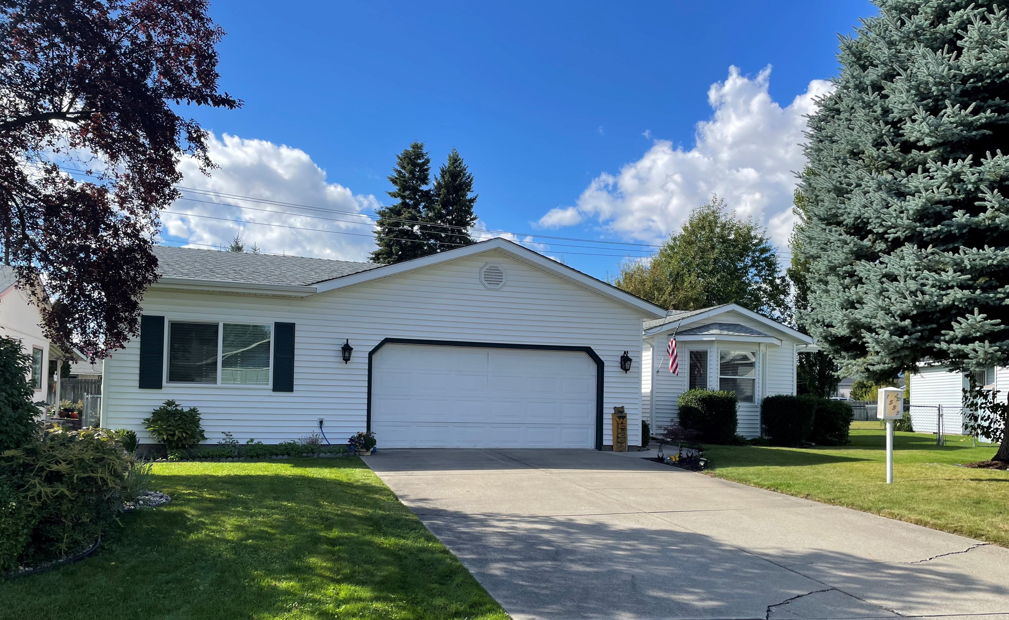
$420,000.00 $409,900.00
CALL DENISE HALL ** EBORALL REALTY, INC. or AARON POGUE 509-362-6506
660-1388 CELL 772-9617 WORK
1535 W. WOODLAWN DRIVE, HAYDEN, IDAHO ** LEISURE PARK RETIREMENT COMMUNITY
www.leisurepark.org

