Amazing Location!
A rare opportunity to own a home abutting the bird sanctuary, which gives you a beautiful open area to look out at, and enjoy while sitting on the covered patio. This home has 9’ ceilings with large windows, so there is a lot of natural light. Recently updated with new granite, flooring, tile back splash, and appliances. Late this summer the exterior hardi plank siding was freshly painted, as well as the interior walls and painted trim package which makes this home feel very clean and fresh. Brand new washer, dryer, and fridge with a bottom freezer. Lots of very custom details throughout.
UPGRADES AND FEATURES
- 2,135 sq. ft. in house
- 3 bedrooms
- 2 bathrooms
- 2 car Extended attached garage
- Rain gutters
- Brick exterior accents
- Fenced yard
- Sprinkler system
- Central air
- Covered Patio
- Granite Countertops
- Kitchen sink disposal
- Kitchen Island
- Hardwood Floors
- 9 Ft. Ceilings
- Average gas and lights bill, High was $265.00, Low was $66.00, Average $148.00 per month.
- Built in 2001
- HOA dues are $60.00/mo. Includes H2O and Clubhouse.
- Sewer billed every other month $105.00 or $52.50/month
- 2020 taxes with homeowners exemption $2090.61.

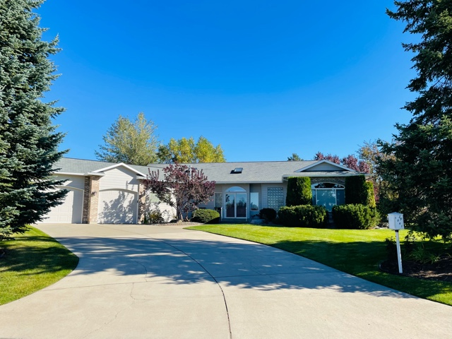

$625,000.00 $599,900.00

** EBORALL REALTY, INC.** Call Denise Hall or Aaron Pogue
Denise- 208-660-1388 CELL 208-772-9617 Work
Aaron- 509-362-6506
1061 W Oakwood Dr. HAYDEN, IDAHO ** LEISURE PARK RETIREMENT COMMUNITY
www.leisurepark.org

